📄 **Churn Analysis Page Documentation**

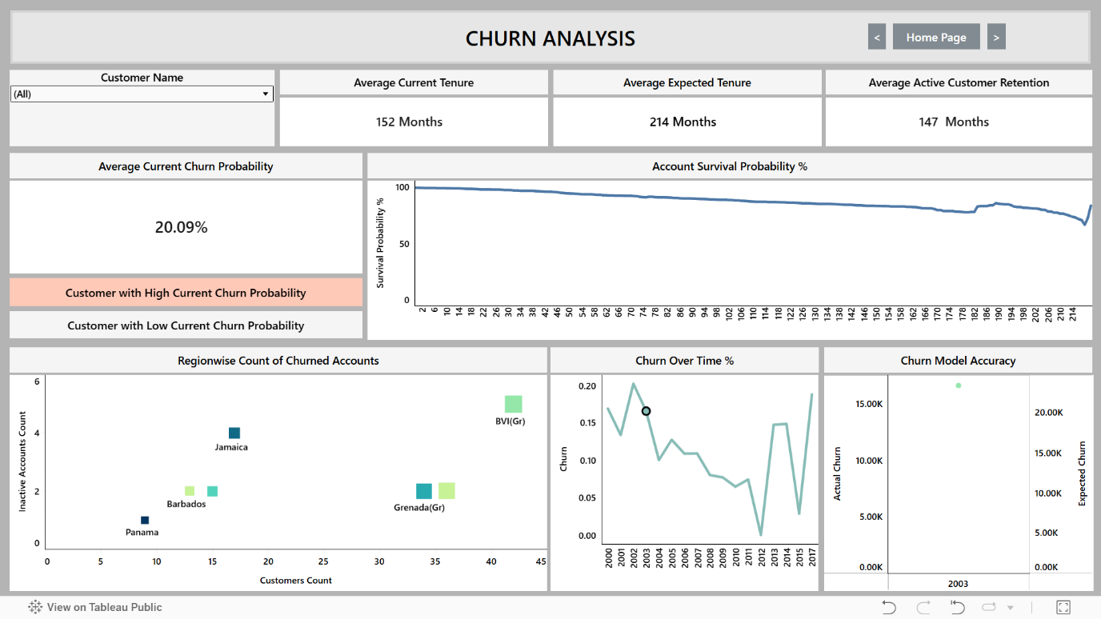

**📍 Purpose**

The Churn Analysis page provides a visual and interactive overview of customer churn behaviour across multiple dimensions (tenure, region, churn rate over time, model accuracy).

It allows users to dynamically filter and cross-filter graphs to analyze churn patterns deeply.  
  
🧩 **UI Elements and Their Functionality**  
  
Section Element Functionality

Header Page Title (CHURN ANALYSIS) Displays the title of the page.

Navigation Buttons (Previous, Home, Next) Navigate to other pages in the dashboard



Filters Customer Dropdown Allows selection of specific customers or "All". Affects all graphs and metrics.

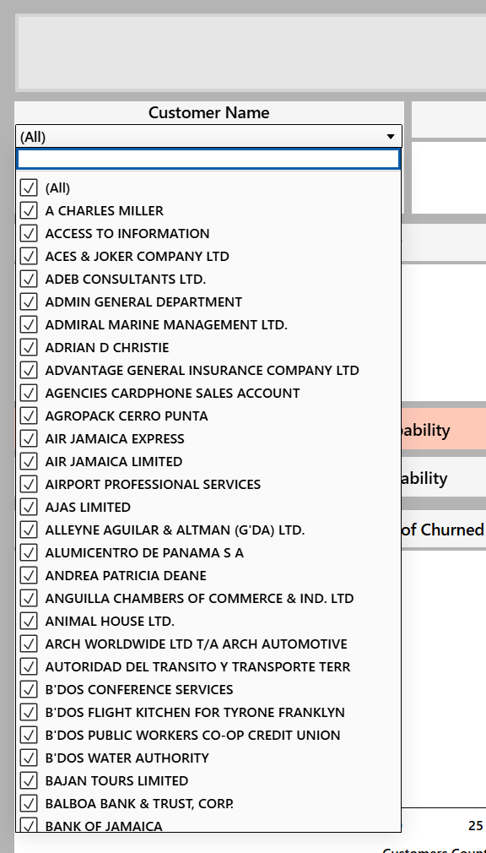

**Metrics - Current Churn Probability**



- Avg Current Tenure

- Avg Expected Tenure

- Avg Active Retention Real-time KPI cards. Update when customer dropdown or graph click filters are applied.

Action Buttons - High Churn Probability Customers

- Low Churn Probability Customers Navigates to /churn_details with query params (type=high or type=low)

**Graphs 1**. **Account Survival Probability**

**2. Region-wise Churn**

When the user clicks on any element on the graph of churn over time it filters the column region name as well as region id in context to the customer name which results that churn over time and churn model accuracy graphs dynamically change with respected to the customer data and the selected region clicked by the user

**3. Churn Over Time (%)**

-When the user clicks on any element in churn over time% it replicates the churn year and churn % which in respect to the specific year selected by user and also all the other graphs dynamically changes based on the year selected.

4. Model Accuracy Dynamic, interactive graphs. Update based on customer selection and graph click-based cross-filtering. Each has an info tooltip describing it.

🔄 Impact:  
- Region-wise Churned Accounts updates based on tenure  
- Churn Over Time filters churn rate by this tenure  
- Churn Model Accuracy reflects only the selected tenure  
- KPIs are recalculated for filtered subset

**📊 How Each Graph Works**  
  
Graph Data Logic X-Axis Y-Axis Notes

Account Survival Probability Shows survival probability of accounts over time based on tenure. Tenure (Months) Survival Probability (%) Clicking filters by tenure_months.

Regionwise Churn Scatterplot comparing customer counts vs inactive accounts across regions. Customers Count Inactive Accounts Clicking filters by region_name.

Churn Over Time (%) Line chart of churn rate year-wise. Year Churn Rate (%) Clicking filters by churn_year.

Model Accuracy Line chart comparing actual vs expected churn year-wise. Year Number of Churn Events Clicking filters by churn_year.

**How Graph Interactions Work (Cross-filtering Behavior)**

When a user clicks on any graph point, a dimension filter is applied (stored inside the dimension_filter_store).  
  
The graphs and KPI cards automatically reload based on the selected dimension filter.  
  
Clicking on:  
  
Churn Over Time → Filters by churn_year   
  
Regionwise Churn → Filters by region_name  
  
Model Accuracy → Filters by churn_year  
  
Account Survival Probability → Filters by tenure_months  
  
Filters are cumulative based on the store until Reset is pressed.  
  
  
🛠️ Query Building and Dynamic Updates  
  
**Function Purpose**

build_churn_rate_sql Builds SQL to fetch churn rate per year based on filters.

build_region_churn_sql Builds SQL to fetch churn and customer count per region.

build_model_accuracy_sql Builds SQL to fetch actual vs expected churn for model evaluation.

build_account_survival_sql Builds SQL to calculate survival probability across tenures.  
build_metrics_sql Builds SQL to fetch average current tenure, expected tenure, and active retention.

build_current_churn_prob_sql Builds SQL to fetch the current churn probability metric.

**👉 All SQLs are refreshed after any dropdown selection or graph click .**  
  
update_sub_queries() → Master callback that reloads all 4 graphs based on customer and dimension filters.  
  
update_metrics() → Reloads all 4 KPI metric cards based on customer and dimension filters.

## 📦 Filter Storage (dimension_filter_store)

|  |  |  |
| --- | --- | --- |
| Trigger Graph | Filter Column | Stored As |
| Survival Graph | tenure_months | dimension_filter_store["tenure_months"] |
| Region-wise Churn | region_name | dimension_filter_store["region_name"] |
| Churn Over Time / Model | churn_year | dimension_filter_store["churn_year"] |

## 📈 Element Changes Summary (on Filter Activation)

|  |  |  |
| --- | --- | --- |
| Element | Changes When... | Filter Column |
| Customer Dropdown | Any change | customer_name |
| Survival Graph | Click event | tenure_months |
| Region-wise Churn | Click event | region_name |
| Churn Over Time | Click event | churn_year |
| Model Accuracy | Click event | churn_year |
| KPIs and Churn Prob. | Any filter applied | tenure, region, churn |

**✅ Summary**

The Churn Analysis page is a dynamic, filterable, and cross-interactive dashboard page where:  
  
Each graph click acts as a new filter for all other graphs + KPIs.  
  
Customer dropdown filters globally across the page.  
  
Reset brings everything back to initial unfiltered state.  
  
Navigation buttons allow moving between dashboard sections.